EXPERIMENT 25:
Create a new GitHub repository for a personal project. Initialize the repository with a README.md file. Then, clone the repository to your local machine, make some changes to the README.md (e.g., add a project description), and push the changes back to GitHub.
Tasks:
- Create a GitHub repository.
- Clone the repository to your local machine.
- Edit the README.md file.
- Stage, commit, and push your changes to GitHub.
Step 1: Create a GitHub Repository
- Open the GitHub website and sign in to your GitHub account.
- Click New Repository and enter a suitable repository name.
- Select the repository visibility as Public or Private.
- Enable the Add a README.md file option.
- Click Create Repository to create the new repository.
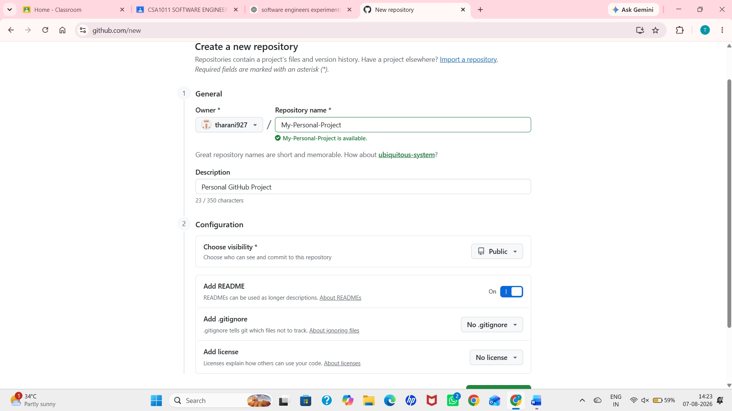
Step 2: Clone the Repository to the Local Machine
- Open the newly created repository on GitHub.
- Click the Code button and copy the HTTPS repository URL.
- Open Git Bash and clone the repository using the following command:
git clone https://github.com/username/My-Personal-Project.git
- Move into the repository folder using:
cd My-Personal-Project
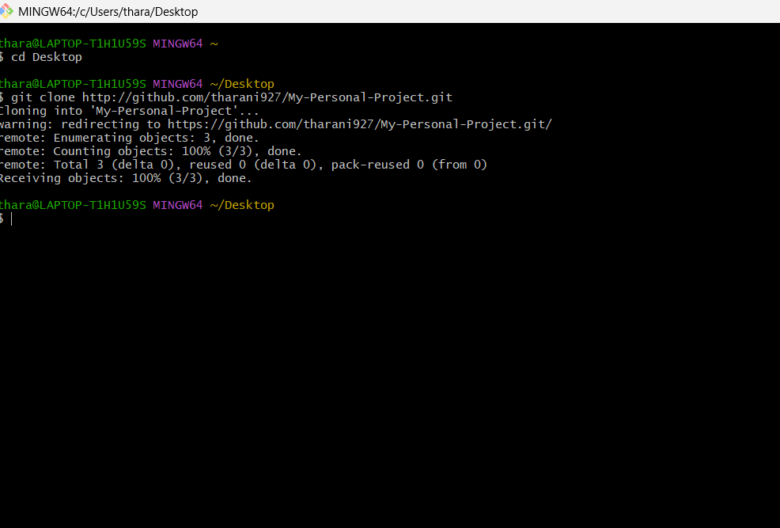
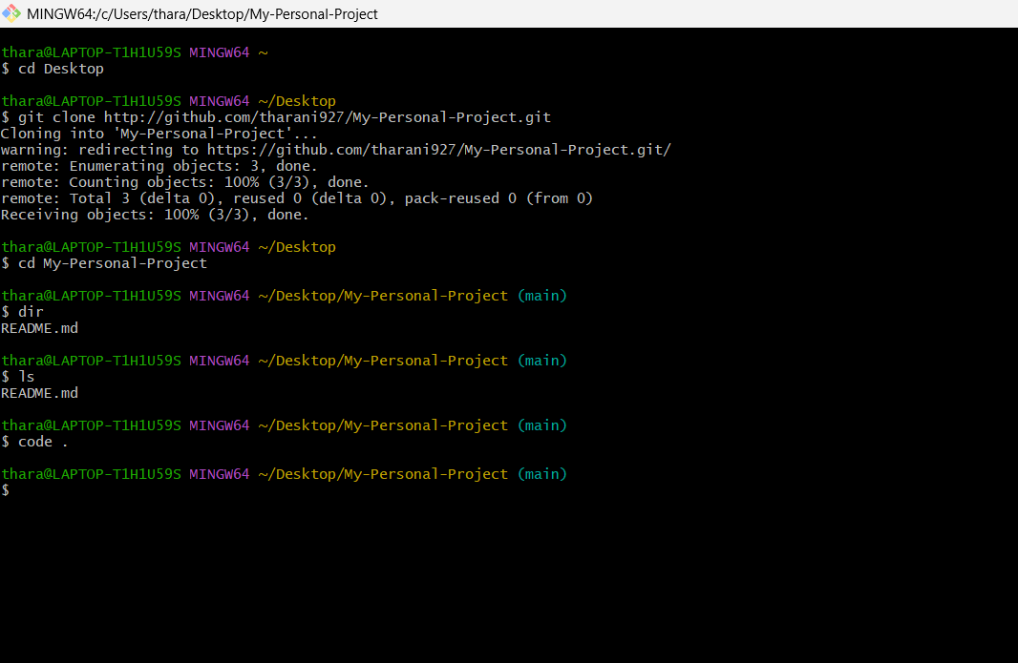
Step 3: Open and Edit the README File
- Open the project folder in Visual Studio Code using: code .
- Open the README.md file.
- Add a brief description of the project, including its purpose and features.
- Save the modified file.
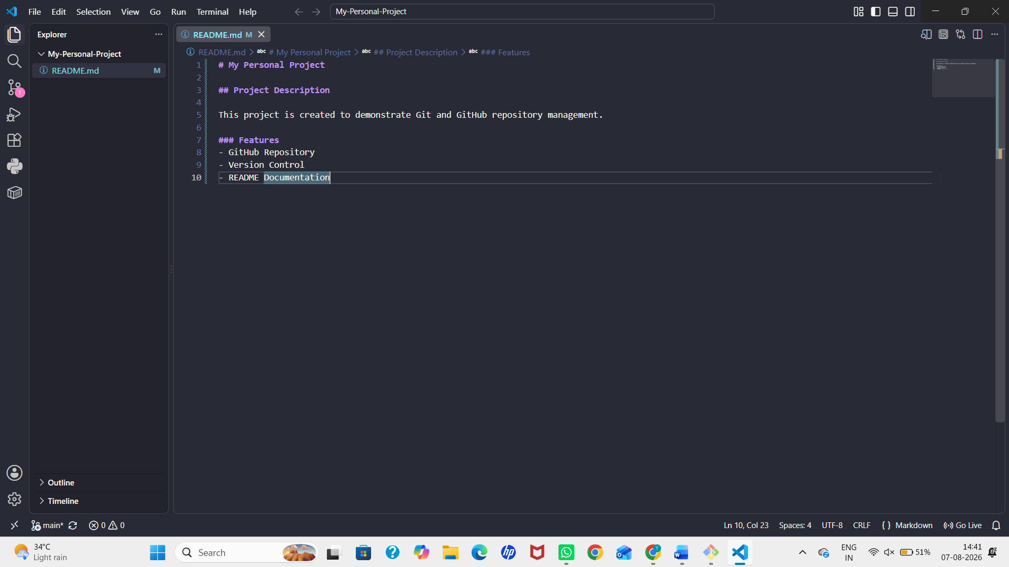
Step 4: Check the Repository Status
- Verify the modified files using the following command:
git status
- Ensure that the README.md file is displayed as modified.
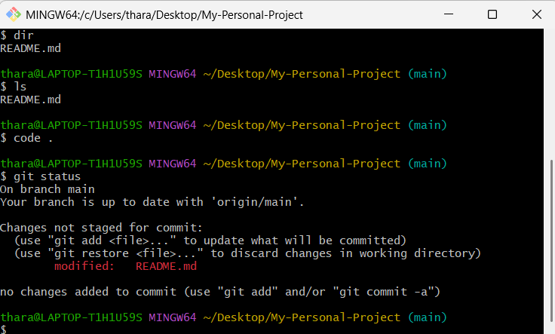
Step 5: Stage the Changes
- Add the modified README file to the staging area using:
git add README.md
- Verify that the file has been staged successfully by executing:
git status
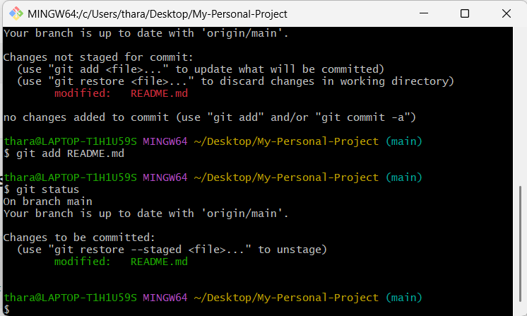

Step 6: Commit the Changes
- Commit the staged changes with a meaningful commit message using:
git commit -m "Updated README with project description"
- Verify that the commit has been created successfully.
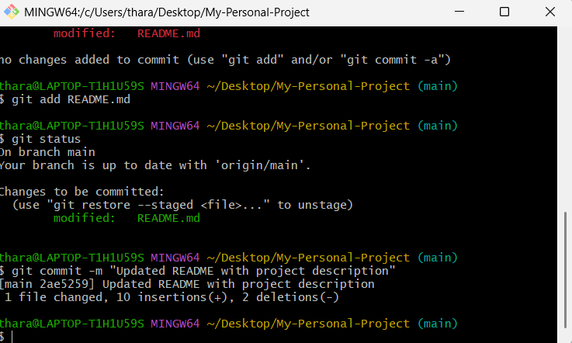
Step 7: Push the Changes to GitHub
- Upload the committed changes to the remote GitHub repository using:
git push origin main
- Wait until the push operation completes successfully.
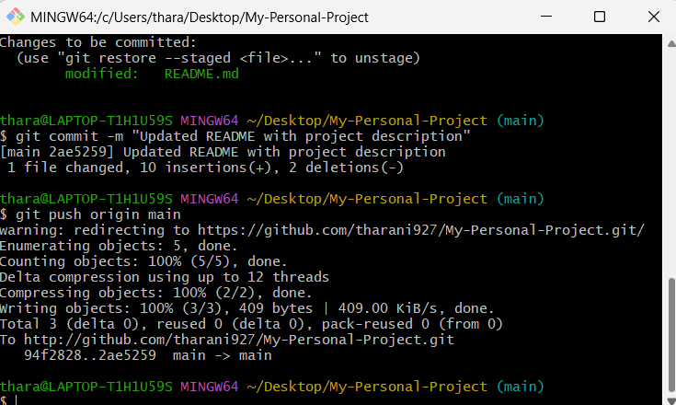
Step 8: Verify the Repository
- Refresh the GitHub repository page.
- Verify that the updated README.md file is displayed.

